**CLOSING OF ORDERS**

**SET-UP OF CONTROL PARAMETER**

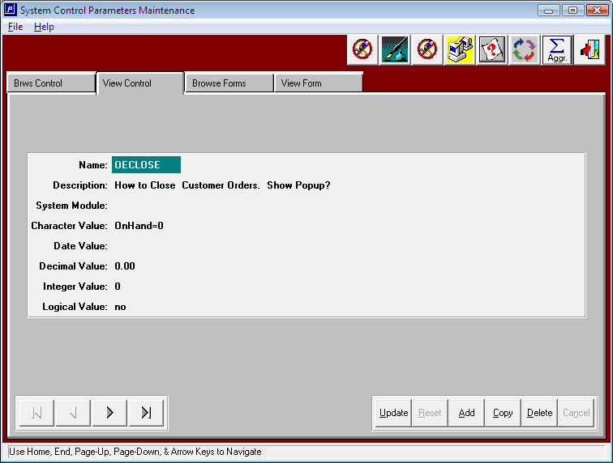

OECLOSE - Methodology to close customer orders.

Character Value options dictate when customer orders are closed. Option are ONHAND=0 or COMPLETE. When value is ONHAND=0 will close the order only when the finished good on hand is zero for all finished goods items. For example, if the quantity produced is greater than the total quantity shipped then the inventory balance would be greater than zero, hence the customer order would remain open. Likewise, an overrun on the job is more than the 10% allowable overrun, then the order will remain open until all the items have been shipped making the on hand quantity = 0 for this particular job number.

Character Value = COMPLETE will close the order when the ship quantity is within the under run of the order quantity, regardless of the quantity on hand.